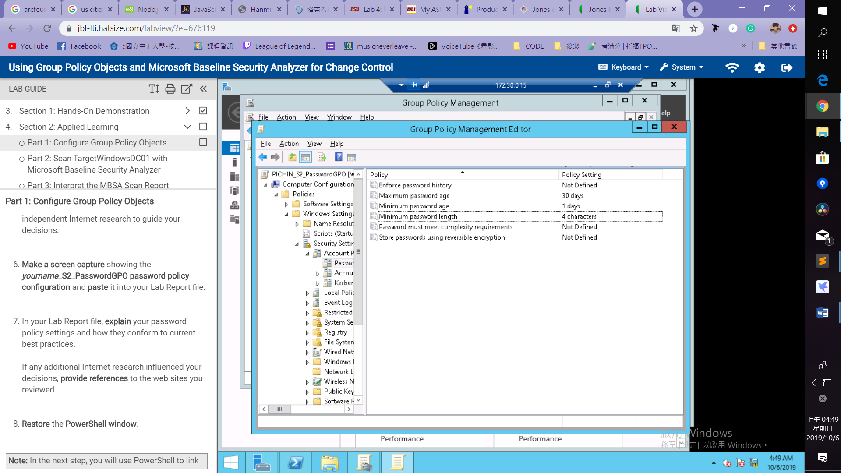

**Explanation:**

Setting Minimum password age to 1 day

If the minimum password age is 0, the password can be changed until the password history requirement is met. The minimum password age of 1 day prevents that.

Setting Maximum password age to 30 days

By setting Maximum password age to a value between 30 and 90 days, an attacker has a limited amount of time in which to compromise a user's password.

Minimum password length to 4 characters

<https://docs.microsoft.com/en-us/windows/security/threat-protection/security-policy-settings/maximum-password-age>

